Step 1: Launch Jupyter notebooks

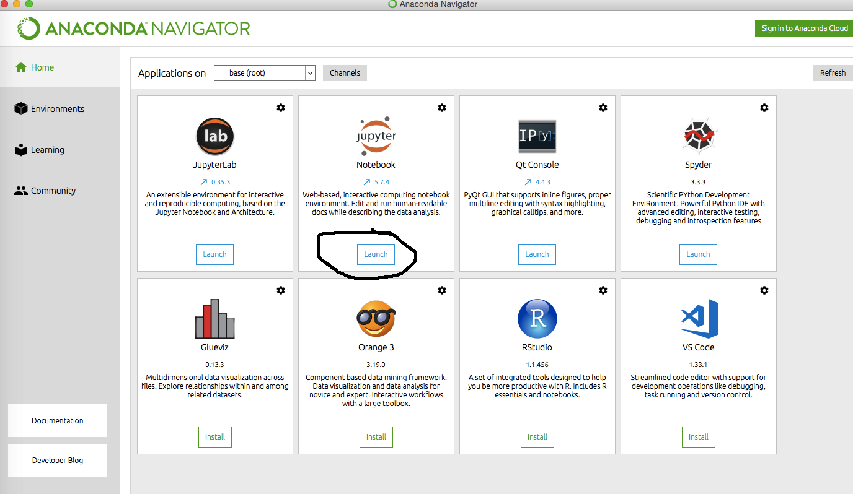

Step 2: Upload the notebook, and than run it

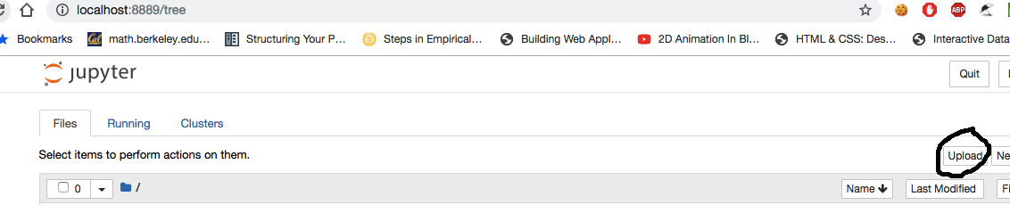

Step 3: Once in the notebook, simply click the run button in each cell to continue

